PRACTICAL- 7

Problem Definition
Process submitted registration/contact form data using PHP. Validate and
sanitize inputs on the server side and store records in CSV or JSON file
format. Display success/error messages.

- Is the form submitted using POST?
Yes. The form uses the POST method to securely send form data to the PHP server.

2. Are inputs validated and sanitized server side?
Yes. PHP validates the submitted data and sanitizes the inputs before storing them.

3. Is file writing handled safely?
Yes. The PHP program opens the CSV/JSON file, writes the validated data, and properly closes the file.
4. Are success and error responses displayed clearly?
Yes. Appropriate success or error messages are displayed after form processing.

SCREENSHOT:

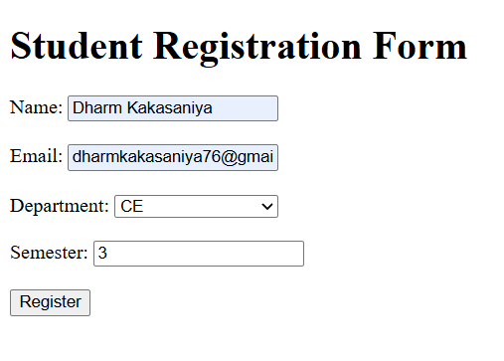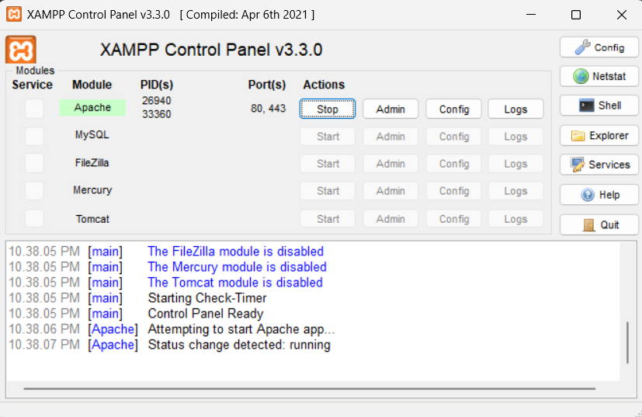

Implementation
● Created a student registration/contact form using HTML and PHP.
● Used the POST method to submit form data to the PHP file.
● Implemented server-side validation for the submitted data.
● Sanitized user inputs before storing them.
● Used PHP file handling functions to open and write data to a file.
● Stored student records in CSV/JSON format.
● Used fputcsv() to store records in a CSV file.
● Displayed appropriate success and error messages after processing.
● Tested the form using valid and invalid inputs.

Challenges
● Handling form data correctly using the POST method.
● Validating and sanitizing user input on the server side.
● Writing data correctly into the CSV/JSON file.
● Handling file opening and closing properly.
● Displaying clear success and error messages.
● Managing invalid or incomplete form submissions.

GitHub Repository
Link: https://github.com/dharmkakasaniya01/Student
Conclusion :

The PHP form was successfully processed using server-side validation and input sanitization. The submitted data was safely stored in a CSV/JSON file, and proper success or error messages were displayed to the user.

